GEORGIA BEEKEEPERS ASSOCIATION
2024 SPRING HONEY SHOW RULES

HOST: Georgia Beekeepers Association (hereinafter “GBA”)
CHAIRPERSON: Brutz English
ARRIVAL TIME: Exhibits will be accepted on Friday evening, February 16, from 3:30 PM until 4:30 PM; and again on Saturday morning, February 17, from 7:15 AM until 9:00 AM. Exhibits will not be accepted after the posted deadline.
LOCATION: Robert Hatcher Conference Center, Middle Georgia State University, Macon, GA
JUDGING: Commences at 9:15 AM, on February 17.
RELEASE TIME: Exhibitors may pick up their entries on Saturday February 17, between 5:00 PM and 6:00 PM. Entries not picked up by the deadline will be disposed of by the Honey Show Committee.
JUDGES: TBA
SECRETARY: TBA

GENERAL RULES OF THE HONEY SHOW:

1. The honey show is open to anyone who is both (a) a current GBA member and (b) a paid attendee of the GBA Spring Conference. The honey show is also open to individuals serving as judges, stewards, or show secretaries; however, no individual serving as a judge, steward, or show secretary may participate in the judging of any exhibit(s) in any category in which they have submitted an exhibit for consideration.
2. Entries must be received between 3:30 PM to 4:30 PM on Friday, February 16, and between 7:15 AM to 9:00 AM on Saturday, February 17th. No entries will be accepted after this deadline.
3. Each Exhibitor must sign an affidavit stating that each exhibit he or she submits was produced by the Exhibitor in conformity with the rules set forth herein.
4. Each Exhibitor may make only one exhibit per class. More than one individual from a family or household may submit exhibits across different categories; however, family members and individuals from common households may not submit multiple exhibits in the same category.
5. With the exception of Extracted Honey, in instances where the exhibit may qualify for
consideration in multiple classes, the Exhibitor shall have the right to choose which class to enter their exhibit; the Exhibitor's selection will not be overturned by the Judge(s); and, said exhibit will be judged based on the criteria set forth in the class selected by the Exhibitor. The Judge shall have discretion to make the final determination as to proper color designation in regard to all exhibits of Extracted Honey.
6. Double Entries are strictly prohibited. A “Double Entry” is when an exhibitor has more than one exhibit placed in a single exhibition class. As used in this rule, the term “Double” is not limited to two, but also encompasses any number greater than one. The Show Secretary shall not knowingly accept any subsequent exhibit which would create a Double Entry. Whenever a Double Entry is created by the decision of a judge in reclassifying an exhibit pursuant to the rules herein, the following procedure shall apply: Prior to the judging of any other exhibits in the affected class, the exhibits constituting the double entry shall be identified and examined by the head Judge; the head Judge shall make a determination as to which of the exhibits constituting the Double Entry is the best under the criteria listed for the affected class; the best exhibit of those comprising the Double Entry will be returned to the show bench, and the other(s) will be disqualified. Whenever a Double Entry results in the disqualification of one or more exhibits, and after the results are publicly announced or posted, it shall be the responsibility of the head judge to personally inform the affected exhibitor of the determination of the Double Entry and subsequent disqualification of the exhibit(s).
7. Unless specifically otherwise provided for under an individual category’s rules, ALL honey, beeswax, propolis, pollen, or royal jelly exhibited, or made part of any exhibit, must be produced by the exhibitor from honeybees owned and kept by the Exhibitor. Any exhibit previously submitted for consideration in any prior host organization honey show, with the exception of mead, is not eligible for this competition.
8. All beeswax items, unless otherwise specifically allowed herein, must be prepared from pure, unadulterated beeswax, free from any additives or enhancements. The use of synthetic, artificial, or adulterated beeswax or drawn honeycomb is strictly prohibited. Exhibits found to be containing any of the above will be disqualified.
9. In regard to the requirement of uniformity, items within or comprising any single exhibit should be alike and matching in every way: jars, containers, closures, contents, composition, orientation, placement, presentation, etc., should be identical across all individual items comprising any single exhibit.
10. Once exhibits have been accepted into the competition by the Show Secretary, they may not be altered in any way.
11. After submitting entries to the Show Secretary, exhibitors may not enter the area where the exhibits have been placed. The Secretary, Stewards or Judges are the only persons who may enter the honey judging area.
12. Judges will enter the honey show area after the close of exhibitor acceptance. This is to ensure as close to a blind judging as possible.
13. Copyright of any submitted recipe, artwork, literary work, or other media remains with the exhibitor, but the host organization has the unrestricted right to publish images of submitted recipes, artwork, literary work, or other media in its newsletter, on its website, and via it’s social media outlets, plus unrestricted rights to use the same in any related material for PR purposes.
14. All exhibits submitted in classes containing the designation “Extracted Honey” are to be presented in one-pound, glass (no plastic), “Queen-line” or “Classic” style jars; any exhibits submitted in any other style of jar or container will be disqualified.
15. Allowances will be made for minor damage to cappings in entries in the comb honey categories, where such minor damage is clearly the result of previous judging in another show.
16. For all mead, beer, and other honey beverage categories, any Exhibitor may, at their discretion, submit a second bottle for chilled tasting. If the Exhibitor chooses to submit a second bottle for chilled tasting, the Exhibitor must submit two identical specimens, both suitable for judging. After the exhibit is submitted, the show secretary will randomly select one of two bottles to be placed in a cooler or refrigerated container. The show secretary will place the other bottle on the judge's bench. Both bottles submitted will be evaluated for the same criteria as a single bottle exhibit.
17. For all exhibits which require, or give the Exhibitor the option of using, any display case, dish, base, frame, stand, or any other exhibition aide, the same should be presented in the same clean, neat, and uniform manner so as to compliment and add merit to the accompanying exhibit.
18. Exhibits must be unmarked or identifiable in anyway, except as provided herein.
19. The Show Secretary will provide each exhibitor identifying labels to be affixed to each exhibit as provided in the rules for each exhibition class. The Exhibitor shall be responsible for placing the ID labels on each exhibit as directed for each exhibition class, unless otherwise specified herein.
20. Each Exhibitor must affirm the inclusion of any image, likeness, or work of any individual other than the Exhibitor, portrayed in or made part of any exhibit, was done so with the prior, informed consent of said individual, and that each exhibit is submitted with the full consent of all parties.
21. Exhibits and other items not retrieved by the deadline posted for pick-up, shall be deemed abandoned, and shall be donated to the Honey Show Committee for future use or disposal. The sponsoring organization, nor the Honey Show Committee, is not responsible for any items left after the pick-up deadline.
22. Any food or beverage item made with any dairy (or other perishable) ingredient(s) or components, or any exhibit that calls for or requires refrigeration for proper storage or holding, should be transported to the honey show, and presented to the Honey Show Secretary in a cooler, insulated/temperature-stable bag, or some other temperature controlled container. The Exhibitor MUST notify the Show Secretary of the necessity of refrigeration or cold storage for any item at the time of submission of the exhibit. Any exhibit, or component of an exhibit, that the Judge(s) deem unfit or unsafe due to a temperature-related storage or transport issue will not be judged and may be subject to disqualification.
23. The Presiding Judge may, based on the number of exhibits submitted, combine one or more classes into a single class, or divide a single class into one or more subclasses.
24. Return/Disposition of Exhibits-
(a) Exhibitors who wish to retrieve their exhibits at the conclusion of the honey show must make arrangements to pick their exhibits up at the specified release time on
February 17th. If an exhibitor wishes to have their exhibit(s) released to a third party or proxy, they must indicate so in writing.
(b) Exhibitors who wish to have their exhibits returned via USPS mail must clearly indicate so on their entry form, AND provide such packaging and packing material(s) as appropriate and adequate to ship their exhibit(s) to the Show Secretary upon submission of said exhibits. Return packaging must include BOTH a self-addressed shipping label AND sufficient pre-paid postage to accommodate the packaged exhibits. Neither the GBA nor any member(s) of the Honey Show Committee shall be responsible for any damage to any
exhibit(s) incurred pursuant to return shipping.
(c) Exhibits and other items not retrieved by the deadline posted for pick-up, shall be
deemed abandoned, and shall be donated to the Honey Show Committee for future use or disposal. The sponsoring organization, nor the Honey Show Committee, is not responsible for any items left after the pick-up deadline.

JUDGING & AWARDS

It is the intention that awards will be given in all classes even if there is only one exhibit in the class. However, in order to receive an award that exhibit must be worthy of placement. Exhibit into a class does not guarantee an award.
All exhibits shall be judged by individuals who are trained and certified AHSTC Honey Judges. The Referee shall have final say in any matter pertaining to the contest if called upon, and shall have the authority to exclude or disqualify any exhibit(s) for good cause. The Judge(s) shall have the final say in regard to the evaluation of any and all exhibits. The decisions of the Referee and Judge(s) are final. After the announcement of awards, any exhibitor may meet with the class judge to discuss their exhibit and ask questions.
Exhibitors found willfully cheating, or purposefully altering or disfiguring an exhibit for the purpose of influencing the validity of judging will be disqualified from the contest, as well as from any future honey shows sponsored by this organization, permanently.

GBA MEMBER CATEGORY PRIZES
PRIZE CARDS will be awarded to the Best in Show winner and all First through Sixth place winners in each class.

THE FOLLOWING 25 CATEGORIES WILL BE ACCEPTED & JUDGED AT THE HONEY SHOW:

EXTRACTED HONEY (Class H)
Light Extracted Honey
Amber Extracted Honey
Dark Extracted Honey
Creamed Honey (soft set)
Creamed Honey (firm set)
Chunk Comb Honey
Cut Comb Honey
Section Comb Honey
Full Frame Comb Honey
Black Jar

BEESWAX (Class W)
Beeswax Block
Six Matching Pieces of Beeswax (1oz-2oz)
Beeswax Candles

ARTS & CRAFTS (Class A)
Artwork Related to Beekeeping
Crafts Related to Beekeeping
Notions, Potions, & Lotions
Photography Related to Beekeeping

BEVERAGES MADE WITH HONEY (Class B)
Traditional Meads (sweet)
Traditional Meads (dry)
Varietal Meads (sweet)
Varietal Meads (dry)
Beers & Ales made w/Honey
Honey Beverages

FOOD ITEMS MADE WITH HONEY (Class F)
Honey Cake (pound cake)
Honey Breads
Honey Confections

RULES FOR INDIVIDUAL CLASSES:
EXTRACTED & COMB HONEY
Extracted Honey
Extracted honey is judged in three subclasses: (a) light, (b) medium or amber, and (c) dark. Exhibitors may submit one exhibit in each of these three subclasses. One exhibit of extracted honey is defined as three (3) identical one-pound jars, as specified in rule #14 under the General Rules of the Honey Show. Closures may be of metal or plastic. Tamper-proof seals are strictly prohibited; any exhibits submitted with any tamper-proof seal(s) will be disqualified. Judges evaluate entries on the following: confirmation with the criteria set forth herein; cleanliness of the jar and lid; correct fill level; uniformity of the jars that comprise the exhibit; cleanliness and clarity of the honey; moisture content (only if needed); and aroma and flavor (for off aromas or flavors). *See Appendix hereafter for notes on correct jars and fill level.

Creamed Honey (soft set)
Creamed or Soft Set honey is honey that has been subjected to a manual or mechanical process to assist and control the otherwise natural process of granulation. An entry of creamed honey is three (3) identical wide-mouth jars, no less than eight ounces (8oz.), nor more than sixteen ounces (16oz.) in net weight. Creamed honey must be displayed in identical, clear, straight-sided, glass jars with one-piece lids. Judges evaluate entries on the following: confirmation with the criteria set forth herein; cleanliness of the jar and lid; correct fill level; cleanliness and purity of the honey; uniformity of product within the jar; fineness of crystals; appropriate set or firmness (should be spreadable but not runny); freedom from foam, frosting, or visible moisture; freedom from added flavors, striation, or colors; uniformity of the jars that comprise the exhibit; aroma and flavor (for off aromas or flavors); and moisture content (only if in question).
The exhibitor must submit a white card describing the process and procedure (including all steps and equipment) employed to produce their creamed honey.

Naturally Granulated Honey (firm set)
Naturally granulated honey is honey which has been allowed to granulate in the jar without the aid of any manual or mechanical assistance or influence from the exhibitor. An entry of Naturally Granulated honey is three (3) identical wide-mouth jars, no less than eight ounces (8oz.), nor more than sixteen ounces (16oz.) in net weight. Naturally Granulated honey must be displayed in identical, clear, straight-sided, glass jars with one-piece lids. Judges evaluate entries on the following: confirmation with the criteria set forth herein; cleanliness of the jar and lid; correct fill level; cleanliness and purity of the honey; uniformity of product within the jar; fineness of crystals; appropriate set or firmness (should be spreadable but not runny); freedom from foam, frosting, or visible moisture; freedom from added flavors, striation, or colors; uniformity of the jars that comprise the exhibit; aroma and flavor (for off aromas or flavors); and moisture content (only if in question).

Chunk Comb Honey
One entry of chunk honey is three (3) identical one-pound jars. Chunk honey must be displayed in straight sided, uncolored, glass, wide mouth, jars. The glass should not be embossed. Such jars are available from many commercial beekeeping suppliers. Only one chunk of comb should be in each jar for competition. The chunk of comb must be in one piece, of uniform thickness, and with a straight mid rib. Virgin comb with this year’s wax is preferred. All foundation should be unwired, thin surplus. The cuts should be clean and uniform. The chunk comb should be cut and sized to appropriately fit the container. The honey should fill the rest of the jar to the correct fill line. The comb should be oriented in the container as found naturally in the hive. Comb with watery cappings should be avoided. The comb should extend the length of the jar. The chunk of comb should account for at least fifty percent (50%) of the internal volume of the jar. Judges evaluate entries on the following: confirmation with the criteria set forth herein; cleanliness of the jar and lid; correct fill level; uniformity of the jars that comprise the entry; cleanliness and clarity of the honey; absence of pollen, brood, uncapped cells, “wet” or “watery” cappings, or travel stains on the cappings; freedom from granulation; absence of floating wax debris in, or on the surface of, the honey; moisture content (only if needed); and aroma and flavor (for off aromas or flavors).

Cut Comb Honey
An exhibit of cut comb honey is three (3) identical boxes. The boxes must be transparent on all sides made for displaying cut comb. Each box of cut comb should weigh a minimum of twelve (12) ounces. The chunk of comb must be in one piece, with a straight mid rib and of uniform thickness. Virgin comb with this year’s wax is preferred. All foundation should be unwired, thin surplus. The cuts should be clean and uniform. There should be no leaking of honey from comb into the box. Judges evaluate entries on the following: confirmation with the criteria set forth herein; uniformity of the items that comprise the entry; uniformity of appearance and color (including the honey in the comb); cleanliness of the jar and lid; completeness of cappings; cleanliness and clarity of the honey; absence of pollen, brood, uncapped cells, “wet” or “watery” cappings, or travel stains on the cappings; freedom from granulation, pollen, and brood; moisture content (only if needed); and aroma and flavor (for off aromas or flavors).

Section Comb Honey
An exhibit of section comb honey is three (3) identical sections. Ross rounds and square section entries must be displayed in the original square or circular section. Sections must be in the containers made for the display of their respective style of section comb honey. The main display panel of the containers may not be obscured or obstructed in any way. One or more of the container(s) may be opened to facilitate the Judge’s evaluation of the exhibit. There should be no leaking of honey from comb into the box. Judges evaluate entries on the following: confirmation with the criteria set forth herein; uniformity of the items that comprise the entry; uniformity of appearance and color (including the honey in the comb); cleanliness of the jar and lid; completeness of capping; cleanliness and clarity of the honey; absence of pollen, brood, uncapped cells, “wet” or “watery” cappings, or travel stains on the cappings; freedom from granulation, pollen, and brood; moisture content (only if needed); and aroma and flavor (for off aromas or flavors).

Full Frame Comb Honey
An exhibit of full frame comb honey is one (1) standard Langstroth style frame of capped honey. The use of plastic foundation is prohibited; exhibits with comb drawn on plastic foundation will be disqualified. Frames must be shown in protective casing without lacing or edging and both sides of the comb should be visible. There should be no leaking of honey from comb into the case. The frame must be easily accessible for judging. Judges evaluate entries on the following: confirmation with the criteria set forth herein; completeness of capping; uniformity of appearance and color (including the honey in the comb); cleanliness of the comb and frame; absence of uncapped cells, “wet” or “watery” cappings, or travel stains on the cappings; freedom from granulation, pollen, and brood; cleanliness of the exposed portions of the frame, including freedom from propolis and bur comb; moisture content (only if needed); and aroma and flavor (for off aromas or flavors). Total weight of the exhibit may be used as a tiebreaker.

Black Jar
An entry consists of not less than two ounces, nor more than four ounces, of pure, unadulterated honey. Entries are to be submitted in black or colored jar which entirely obscures the contents of the jar. The required jar will be provided by the Show Secretary at the sign-in table, and the Exhibitor will transfer their entry into the jar and return the exhibit to the Show Secretary. Judges evaluate entries for flavor only.
*In the Black Jar class, only a First Place prize will be awarded.

BEESWAX & CANDLES
Beeswax Block
An exhibit consists of one (1) block of pure beeswax. The block must weigh between one to two pounds, no more, and should have thickness no greater than 1.5 inches. The wax should be clean, and free of impurities. The block should be smooth-surfaced and free of blemishes, decorations or embellishments. *The word “BEESWAX” imprinted in the wax is NOT considered a decoration or embellishment, and shall not be counted against any entry, except for imperfections or defects in the casting thereof. Beeswax wax should be of a vibrant, natural beeswax color, and should have a pleasant, natural beeswax fragrance. The block should be submitted on a plain, white plate or board (which may be made of paper, foam, cardboard, or any similar material), in a zip-top bag. Alternatively, at the Exhibitor’s option, the block may be presented in a protective display case. If a show case is used, it must not exceed 12” (length) x12” (width) x 4” (depth), and the wax block must be readily accessible for judging. The show case will not be judged, aside for cleanliness. Judges evaluate entries on the following: confirmation with the criteria set forth herein; cleanliness; color; finish; and aroma (for off aromas).

Six Identical Pieces of Beeswax
An exhibit is defined as six (6) identical pieces of beeswax. Each piece should be not less than one ounce (1 oz.), nor more than two ounces (2 oz.). The beeswax wax should be of a vibrant, natural beeswax color, and should have a pleasant, natural beeswax fragrance. The wax should be clean, and free of impurities. The pieces should be smooth-surfaced, free of blemishes, and identical in every way. The pieces should be submitted on a plain, white plate or board (which may be made of paper, foam, cardboard, or any similar material), in a zip-top bag. Alternatively, at the Exhibitor’s option, the pieces may be presented in a protective display case. If a show case is used, it must not exceed 12”(length) x 12”(width) x 4”(depth), and the pieces must be readily accessible for judging. The show case will not be judged, aside for cleanliness. Judges evaluate entries on the following: confirmation with the criteria set forth herein; cleanliness; color; aroma (for off aromas); uniformity; casting flaws; and sharpness of detail.
Beeswax Candles
An exhibit is defined as three identical beeswax (3) candles. The beeswax wax should be of a vibrant, natural beeswax color, and should have a pleasant, natural beeswax fragrance. The wax should be clean, and free of impurities. Wicks must be trimmed to one-half inch in length. The candle must have a flat base with wicks waxed and well centered. One of the candles in each exhibit will be lit by the judge and allowed to burn. The exhibit must be presented with one (1) free-standing, fire-proof base or candleholder. Items comprising the exhibit should be uniform in every aspect, including height, thickness, weight, appearance, and performance (where appropriate). Judges evaluate entries on the following: confirmation with the criteria set forth in herein; cleanliness; color; aroma (for off aromas); proper wicking; performance; uniformity; rolling flaws; and sharpness of detail.

ARTS & CRAFTS RELATED TO BEEKEEPING
Artwork Related to Beekeeping
Artwork is the expression or application of human creative skill and imagination, often in a visual form such as (but no way limited to) painting or sculpture, producing works to be appreciated primarily for their beauty or emotional power. An Exhibitor may submit one example of any beekeeping-related artwork of their own composition. The artwork must be related to some aspect of apiculture, must be the original composition of the Exhibitor. The artwork must be mounted or freestanding in design. Judges evaluate entries on the following: confirmation with the criteria set forth in herein; subject matter, aesthetic appeal, technical proficiency, creativity, and originality. *A white index card with a description of the item must accompany each entry.

Crafts Related to Beekeeping
A craft is a pastime or a profession that requires particular skill and knowledge of a specialized field or subject. Craftsmanship typically denotes experience, knowledge, skill, and expertise in making things by hand. An Exhibitor may submit one example of any beekeeping-related craftwork of their own composition. The craftwork must be related to some aspect of apiculture, and must be the original composition of the Exhibitor. The craftwork must be mounted or freestanding in design. Judges evaluate entries on the following: confirmation with the criteria set forth in herein; subject matter, aesthetic appeal, technical proficiency, creativity, and originality. *A white index card with a description of the item must accompany each entry.

Notions, Potions, & Lotions
An Exhibitor may submit one example of any health, bath, or beauty product of their own creation, not otherwise encompassed in another class in this show. The recipe for the exhibit must include honey, beeswax, and/or propolis produced by the Exhibitor. Entries are to be presented in a resealable, unembellished container appropriate to the item. Entries should not be less than one ounce (1oz.), nor more than eight ounces (8oz.) in weight. All entries will be sampled. Judges evaluate entries on the following: appearance, uniformity, texture, aroma, tactile feel, functionality, and originality. *A white index card with a description of the item and the recipe (including all ingredients & procedure) must accompany each exhibit.

Photographs Related to Beekeeping
An Exhibitor may submit one example of any beekeeping-related photography of their own composition. The photograph(s) must be related to some aspect of apiculture, and must be the original composition of the Exhibitor. All photographs comprising each exhibit must be at least 5”x7” in size. The photograph(s) must be mounted, matted, or framed. The photograph(s) must stand up for display; either equipped with an easel back, or the entrant must provide an easel on which to display the exhibit. Judges evaluate entries on the following: subject matter, aesthetic appeal, technical proficiency, creativity, and originality. *A white index card with a description of the item must accompany each exhibit.

BEVERAGES MADE WITH HONEY
Mead
Mead is judged in four subclasses: (a) Traditional Sweet, (b) Traditional Dry, (c) Varietal Sweet, and (d) Varietal Dry. Traditional meads contain only honey, water, yeast, and no other flavoring additives. Varietal meads include melomels, pymets, cysers, metheglins, hippocras, braggots, sac meads, and desert meads. Entrants may submit one exhibit in each of these respective subclasses. An exhibit consists of one, clear, uncolored, glass standard 750ml wine bottle. Punt bottles are acceptable as long as they are standard pattern wine bottles. Tee, tasting, or mushroom-style corks are acceptable closures; traditional, inserted corks will not be accepted by the Show Secretary. Bottles should be filled to a point precisely two (2) centimeters from the bottom of the cork. All mead must be produced from honey produced by the Exhibitor. All entries will be tasted. Judges evaluate entries on the following: confirmation with the criteria set forth herein; cleanliness of the container and closure; cleanliness and clarity of the contents; correct fill level; color; clarity; lack of sediment; aroma; flavor; body; balance; complexity; finish; and influence of honey on the final product. *A white index card with a description of the type or style of mead and the full recipe (including all ingredients) must accompany each exhibit.

Beer & Ale Made with Honey
The Exhibitor may submit one example of a beer or ale prepared by the Exhibitor. An exhibit consists of one (1) glass, unembossed, standard 12oz or 16oz beer bottle. Clear glass is preferable, however colored glass is acceptable. Standard, unmarked crimped closures or lightening closures will be accepted. Bottles should be filled to not less than 1” nor more than 1.5” from the bottom of the cap or closure. All beer and ale must be produced from honey produced by the Exhibitor. All entries will be tasted. Judges evaluate entries on the following: confirmation with the criteria set forth herein; cleanliness of the container and closure; cleanliness and clarity of the contents; correct fill level; color; clarity; lack of sediment (except where appropriate); aroma; flavor; body; balance; complexity; finish; and influence of honey on the final product. *A white index card with a description of the type or style of beer or ale and the full recipe (including all ingredients) must accompany each exhibit.
The Exhibitor shall place one ID label, as provided by the honey show Secretary, on the front, bottom, center of the bottle, ½ inch from the bottom of the bottle. Additionally, the Exhibitor shall place one ID label, as provided by the honey show Secretary, on the front, bottom, right-hand corner of the white card accompanying the exhibit. *In the event an Exhibitor elects to submit a second bottle to be chilled for tasting, the Show Secretary will affix an additional identifying label around the neck of the bottle to be chilled.
Honey Beverages
The Exhibitor may submit one example of a honey beverage prepared by the Exhibitor. An exhibit consists of one (1) glass, unembossed, standard 12oz or 16oz beer bottle. Clear glass is preferable, however colored glass is acceptable. Standard, unmarked crimped closures or lightening closures will be accepted. Bottles should be filled to not less than 1” nor more than 1.5” from the bottom of the cap or closure. All honey beverages must be produced from honey produced by the Exhibitor. All entries will be tasted. Judges evaluate entries on the following: confirmation with the criteria set forth herein; cleanliness of the container and closure; cleanliness and clarity of the contents; correct fill level; color; clarity; lack of sediment; aroma; flavor; body; balance; complexity; finish; and influence of honey on the final product. *A white index card with a description of the type or style of beverage and the full recipe (including all ingredients) must accompany each exhibit.

FOOD ITEMS & BAKED GOODS

Honey Pound Cake
A pound cake is a rich, sweet, dense cake that's traditionally made with one pound each of flour, butter, eggs, and sugar. The Exhibitor may submit one example of a pound cake baked by the Exhibitor. An entry consists of one (1) cake. The recipe for the entry must include honey produced by the Exhibitor. Exhibits may NOT be dusted, frosted, iced, or glazed. Exhibits must be baked in either a tube or Bundt style cake pan.
All ingredients in the honey pound cake must come from the list contained below. The use of any ingredient(s) not contained in the list below is strictly prohibited. Exhibits may contain any of the following ingredients, in any amount(s) or combination(s), at the Exhibitor’s discretion:
- Flour - Milk
- Butter, margarine, lard, or vegetable shortening - Buttermilk
- Eggs - Cream
- Baking powder - Evaporated Milk
- Baking Soda - Sour Cream
- Salt - Almond Extract
- Sugar - Vanilla Extract
- Honey
Entries are to be presented on a cardboard base, in a standard, unembellished, cardboard baker’s or cake box; cake boxes with clear windows are also acceptable. All entries will be tasted. Judges evaluate entries on the following: appearance, uniformity (of mixing and baking), moistness, texture, aroma, flavor, and influence of honey on the finished product. *A white card with a description of the item and the recipe, including all ingredients, ingredient quantities, & procedure, must accompany each entry.

Breads Made with Honey:
The Exhibitor may submit one example of a bread baked by the Exhibitor. An exhibit consists of one (1) standard size loaf, or two (2) rolls, biscuits, muffins, or mini-loaves. The recipe for the exhibit must include honey produced by the Exhibitor. All entries will be tasted. Entries are to be presented on a cardboard base, in a standard, unembellished, cardboard baker’s or cake box; cake boxes with clear windows are also acceptable. All entries will be tasted. Judges evaluate entries on the following: appearance, uniformity, moistness, texture, aroma, flavor, influence of honey on the finished product, and originality. *A white index card with a description of the item and the recipe (including all ingredients & procedure) must accompany each exhibit. *In the event an exhibit in this class is too large to fit in a commonly available cake box, the exhibitor may submit his/her exhibit in some other appropriate, re-sealable container.

Honey Confections
A confection is any cookie, candy, pastry, tart, petit four, chocolate, or other sweet food or delicacy, not otherwise encompassed in another class in this show. The Exhibitor may submit one example of a confection prepared by the Exhibitor. An exhibit consists of six (6) pieces or servings. The recipe for the exhibit must include honey produced by the Exhibitor. All entries will be tasted. Entries are to be presented on a cardboard base, in a standard, unembellished, cardboard baker’s or cake box; cake boxes with clear windows are also acceptable. All entries will be tasted. Judges evaluate entries on the following: appearance, uniformity, moistness, texture, aroma, flavor, influence of honey on the finished product, and originality. *A white index card with a description of the item and the recipe (including all ingredients & procedure) must accompany each exhibit.

Appendex
*The correct jars for extracted honey entries.
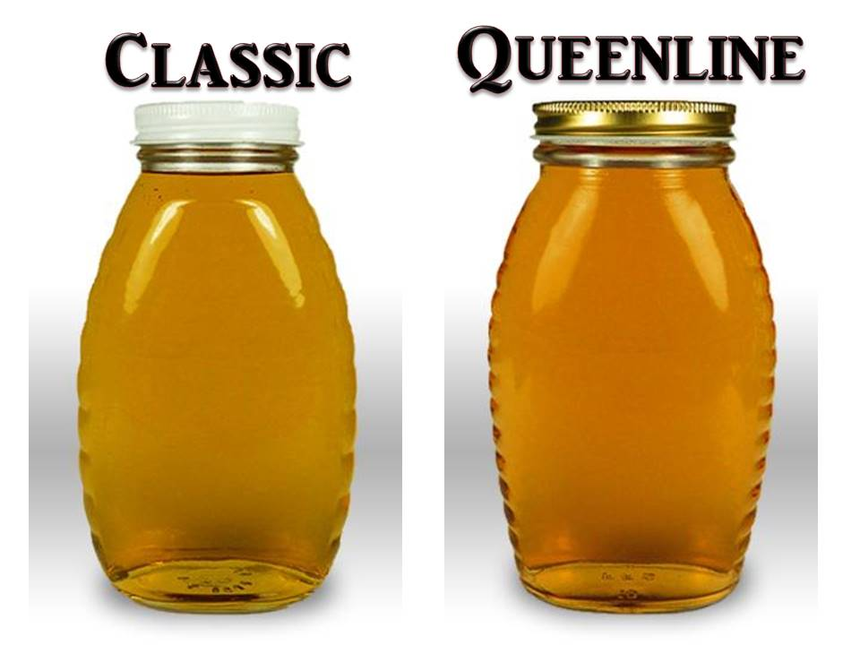

*Notes on correct fill level:
-The correct fill level on a “Queen-line” or “Classic” style honey jar is at the fill ring of the jar. The
fill ring is the raised ridge or ring of glass immediately above the shoulder of the jar, and
below the threads. It can be distinguished from the threads in two ways: a) the fill ring forms
a complete circle, without ends; and b) the fill ring will be completely parallel with the bottom
and top of the jar. There should be enough honey in the jar to clearly touch the fill ring,
without going over.
-Liquid honey in a circular shape forms a concave surface sometimes referred to as a meniscus.
For purposes of filling jars, the edge of the meniscus should clearly touch the fill ring, without
going over.
-When the lid is properly closed on the jar, there should be no visible light beneath the bottom of
the lid and the surface of the honey.
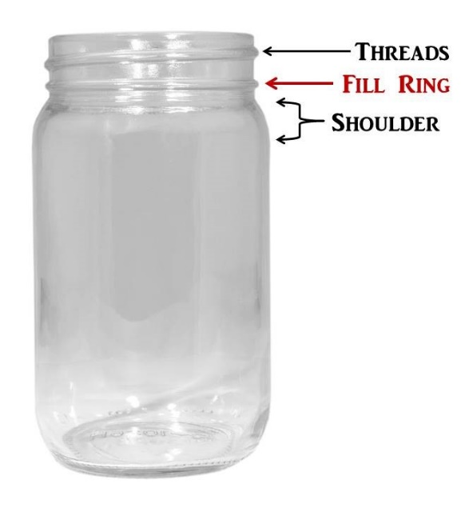
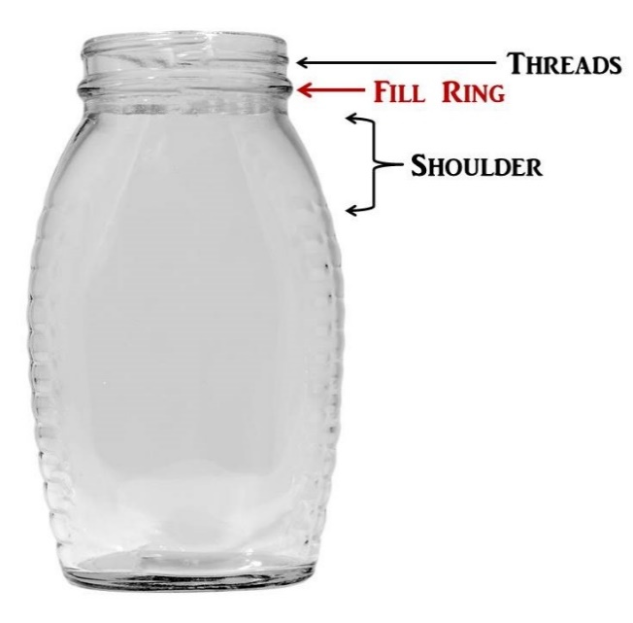
-A jar of honey being over-filled is preferable to one being under filled.

